**Design & Technology**

**User Centred Design**

**Materials required for questions**

* Pencil
* Rubber
* Calculator

**Instructions**

* Use black ink or ball-point pen
* Try answer all questions
* Use the space provided to answer questions
* Calculators can be used if necessary
* For the multiple choice questions, circle your answer

**Advice**

* Marks for each question are in brackets
* Read each question fully
* Try to answer every question
* Don’t spend too much time on one question

**Good luck!**

**Q1.** What is iterative design?

**A** A product is never change throughout

the design process

**B** A product is continually analysed, tested

And revisited throughout the design

process

**C** A product is developed once throughout

The design process

**Q2.** What is an advantage of user-centred design?

**A** The user is put at the centre of design

**B** The user is consulted at the end of the

design

**C** The user is not consulted during the

Design process

**Q3.** Which of these is not an advantage of collaboration when designing?

**A** It can help overcomes design fixation

**B** it is a way to take ideas from others

**C** it is an excellent way of gaining feedback

**Q4.** Why is an analysis of a design context so important?

**A** So the designer can gain a clear

Understanding of the design problem

**B** so the designer can test the models that

Have been produced

**C** so the best ideas can be sketched

**Q5.** Which of the following statements is representative of iterative design?

**A** A system approach

**B** A process of continual improvement, of

a concept, prototype, design or product,

with model making, sketching, client

feedback applied when required

**C** A linear design process, whereby by

One stage follows another

**Q6.** The application of user centred can lead to innovative products being created. Explain the concept of user centred design **(4 marks)**

**Q7.** Designers must prioritise form or function when designing products. Discuss how the designer of the PS5 controller has balanced form and function in the design **(6 marks)**

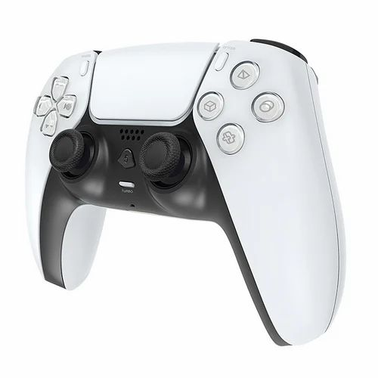

**Q8.** The image below shows a picture of a multi-purpose chair that can be used from birth to four years of age.

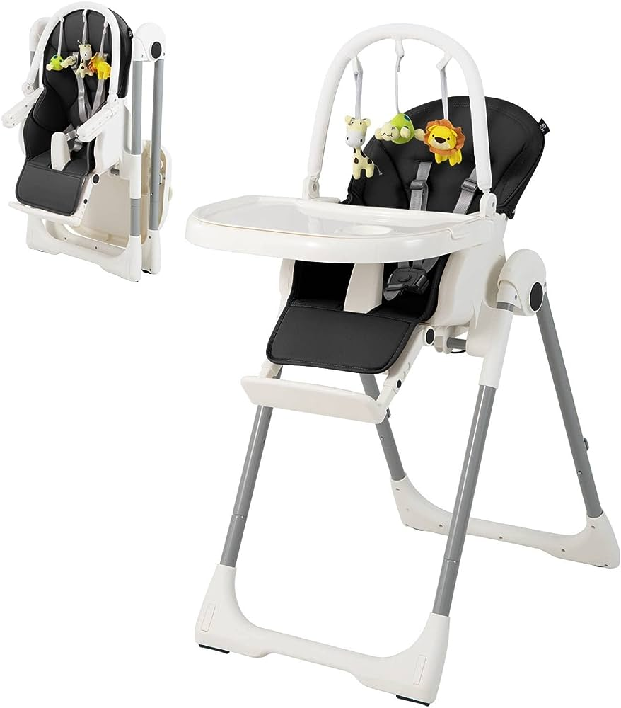

Key design features of the multi-purpose chair include:

* Folding frame with four lockable wheels
* Removable tray and removable activity centre
* Padded reducer to suit different ages / sizes of children
* 8 adjustable height positions
* Adjustable footrest positions
* Reversible padded seating
* Security harness.

Discuss how user centred design may have been used to ensure that the multi-purpose chair is fit-for-purpose for the target market group **(9 marks)**

**Answers**

**Q1. B  
Q2. A  
Q3. C  
Q4. A**

**Q5. B**

**Q6.**

* Designers recognize that they do not fully understand how users will instinctively interact with a product (1) so observing consumers use a design is essential. (1)
* It is a reiterative process (1) in order to achieve the optimum outcome. (1)
* The design is adapted to suit the user (1) rather than the user adapting to suit the design. (1)

**Q7.**

Candidates might refer to the following in their responses:

* Form follows function
* Function follows form
* Shape/form
* Key functions
* Ergonomics and anthropometrics
* Demographics of the user group
* Proximity of key controls to fingers and thumbs
* Range of hand movement
* Shape of handles
* Comfort in use
* Ease of use
* Aesthetics

**Q8.**

Candidates might refer to the following in their responses:

* Focus on users and their needs
* Framework process
* Two users – the baby and the adult
* Anthropometrics and ergonomics of both users
* Use of investigative methods
* Use of generative methods
* Iterative process
* User feedback throughout
* Understanding the context of use
* Specifying user requirements
* Production of design solutions
* Evaluation/testing against requirements
* Use of consumer panels
* Real life prototype testing
* More likely to meet expectations and requirements
* Helps designers understand the diversity of cultures
* Key design features of the chair and how USD may have influenced these features.